**Weekly WIP & AR Aging Report Automation**

**Background**

There’s a weekly report that the team needs to send to our internal business stakeholders and due to some system migration issue we have more data sources to be compiled and cleaned to produce this report.

**Problem Statements**

1. Time Consuming ~1 hour in manual Data Cleaning and Data Modelling
2. Potential Human Errors during the process

**Automation Tools**

1. Power Query – automated Data Cleaning and Data Modelling process since every week the process is static.
2. VBA – automated Data Source import and queries refresh

**Methodology**

1. I will extract the datasets I need from SAP and Power BI bookmarks (saved layouts) and save them onto my local PC.
2. Next, I import source data by clicking the macro buttons, and the old data source within the queries will be replaced by the new data source that I have just imported, then refreshed automatically.
3. I have created a macro that refreshes all worksheets at once so that I can even confirm the reports' last refreshed time.
4. I have also created a macro to refresh the data source file path so that I can confirm I have used the correct datasets.
5. There are two advanced Excel functions (LEFT and TEXTAFTER) that I used to extract the period from the data source file path.

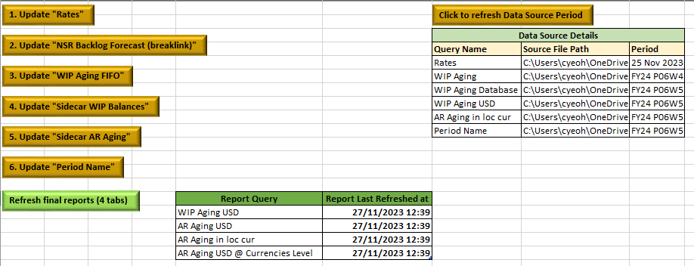

**Achievements**

1. Time Saving from ~1 hour to 3-5 mins as the report is refreshed with new data source at few clicks of macro buttons.
2. Human Error risk is prevented as data cleaning and data modelling process is automated.
3. The data source path and the last refreshed date of the reports are readily available.